**PRACTICAL-3**

**AIM**

Perform following using Cloud Analyst:

1. Install a Cloud Analyst and Integrate with NetBeans. Monitor the performance of an Existing Algorithms given in Cloud Analyst.
2. Modify or propose a new load balancing algorithm compatible with Cloud Analyst

**THEORY**

**CloudAnalyst:**

* Cloud Analyst is a tool developed at the University of Melbourne whose goal is to support evaluation of social networks tools according to geographic distribution of users and data centers.
* In this tool, communities of users and data centers supporting the social networks are characterized and, based on their location; parameters such as user experience while using the social network application and load on the data center are obtained/logged.

**IMPLEMENTATION**

* Download CloudAnalyst
* Extract Files from the Zip file which will give following folder structure.
* If you want to Run from Command line then type the following command in cmd.

java -cp jars\simjava2.jar;jars\gridsim.jar;jars\iText-2.1.5.jar;classes;. cloudsim.ext.gui.GuiMain

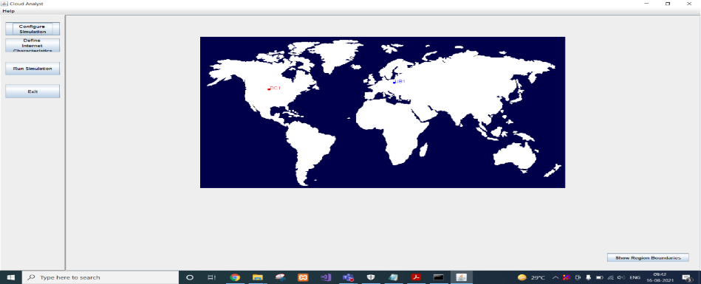

* Click on CONFIGURE Simulation.
* Data Center Configuration where you can manage Physical Hardware Details of Data center.

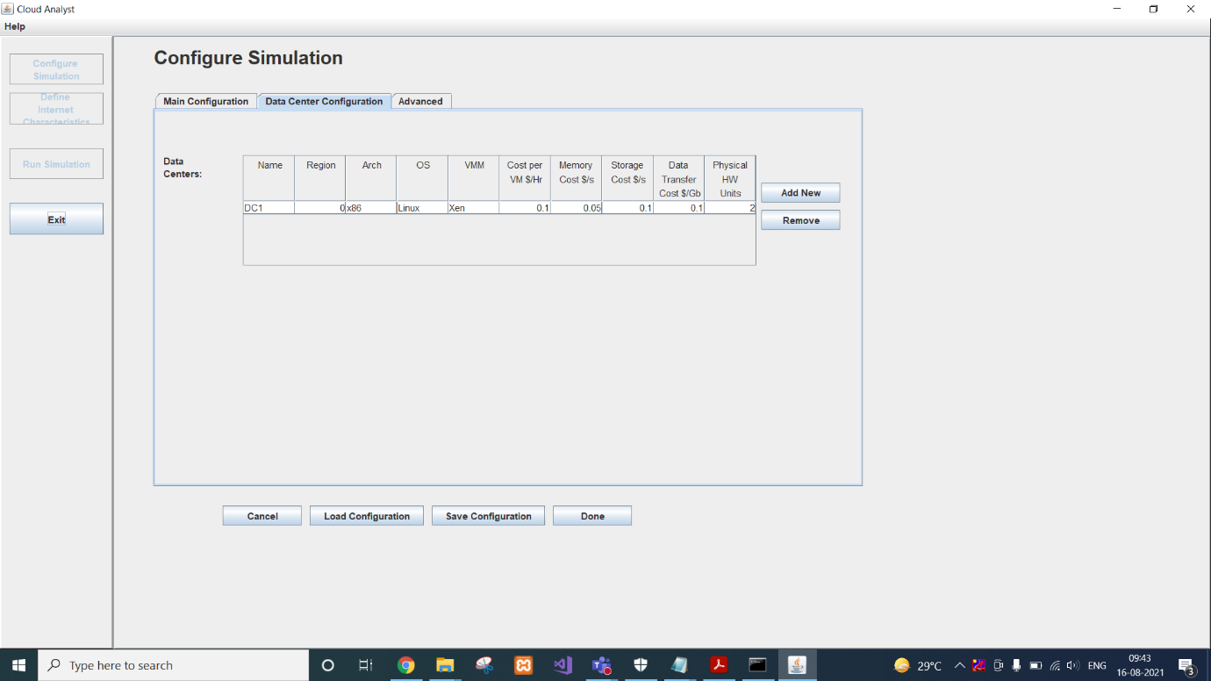

* We can double click on Datacenter to open Host information.

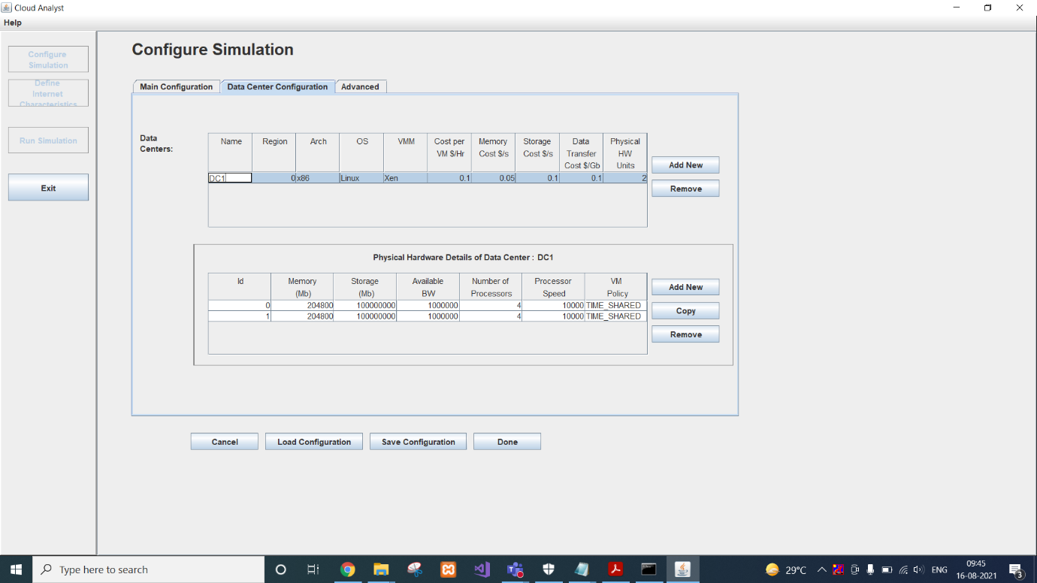

* We can click on any host and copy it as many time as we want.

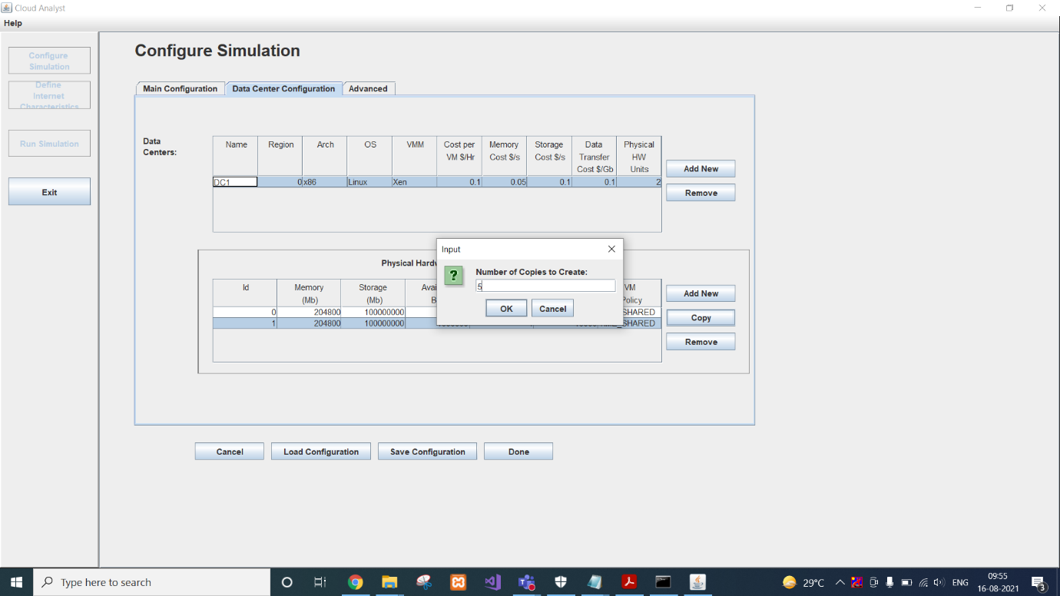

* Here we are creating 5 copies of one of them so it will give us total of 6 hosts.

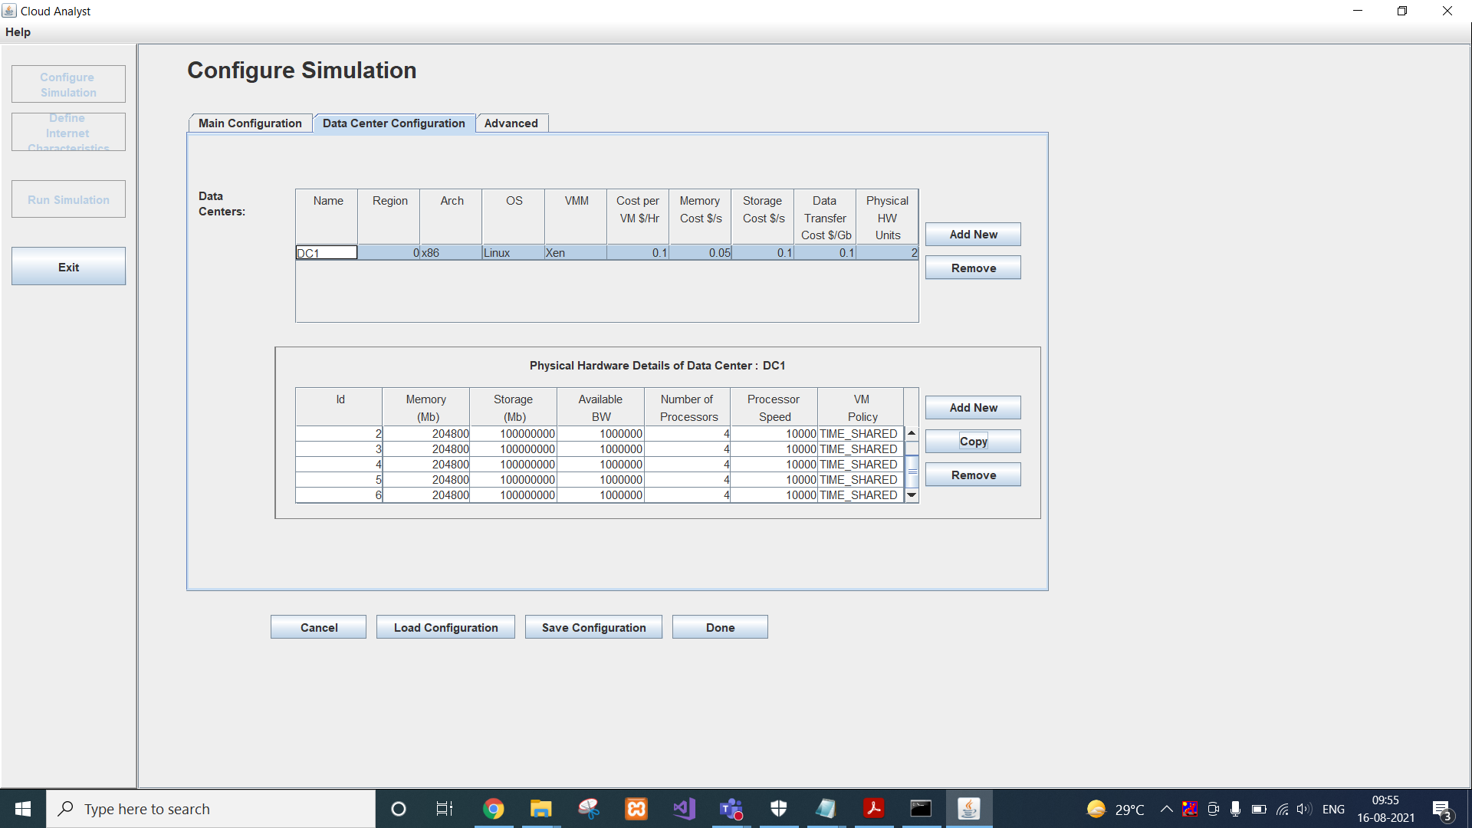

* We can also configure advanced settings.

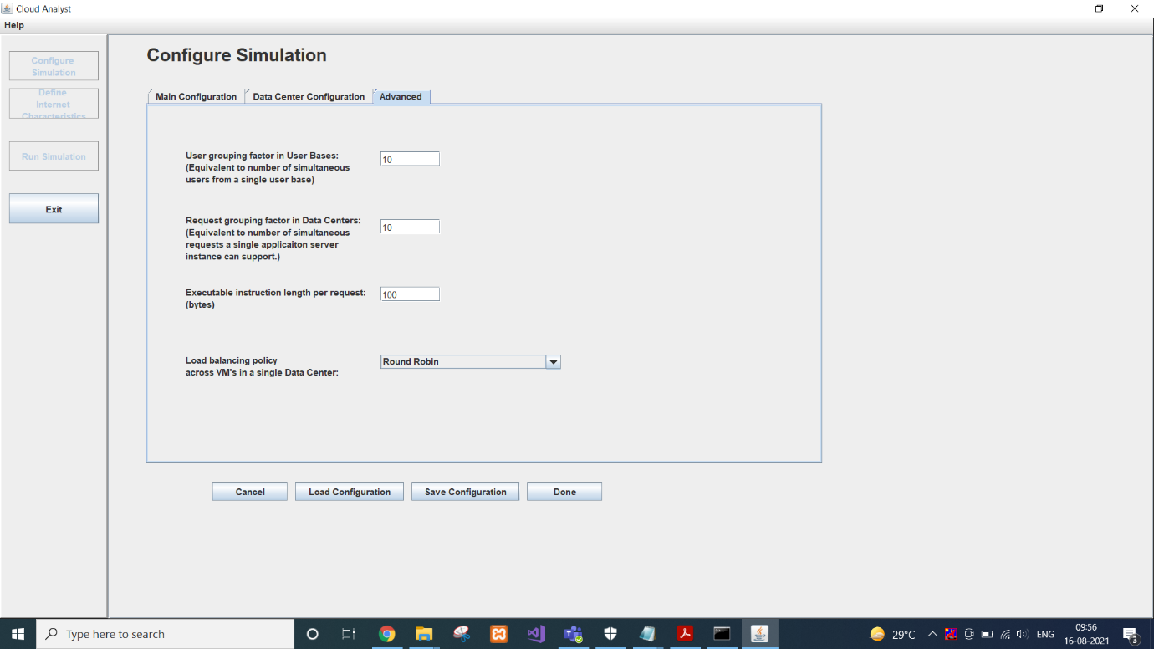

* We can also customize user base that is models a group of users and generates traffic representing the users.

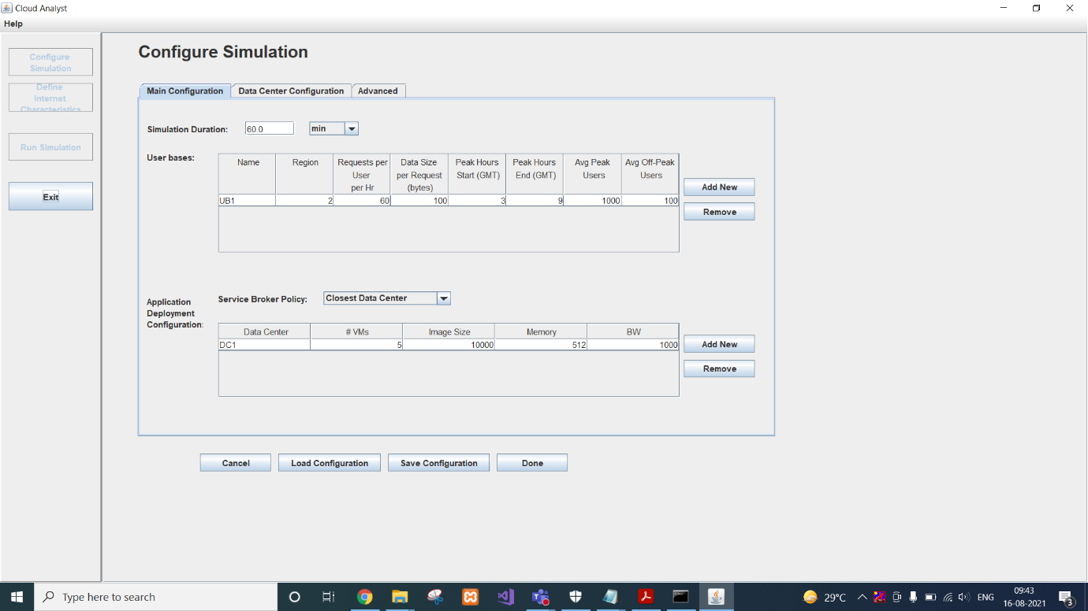

* You can Save this Configuration as well in case you want to use it later. It is stored as .sim file. XML data is generated and saved as Sim file.

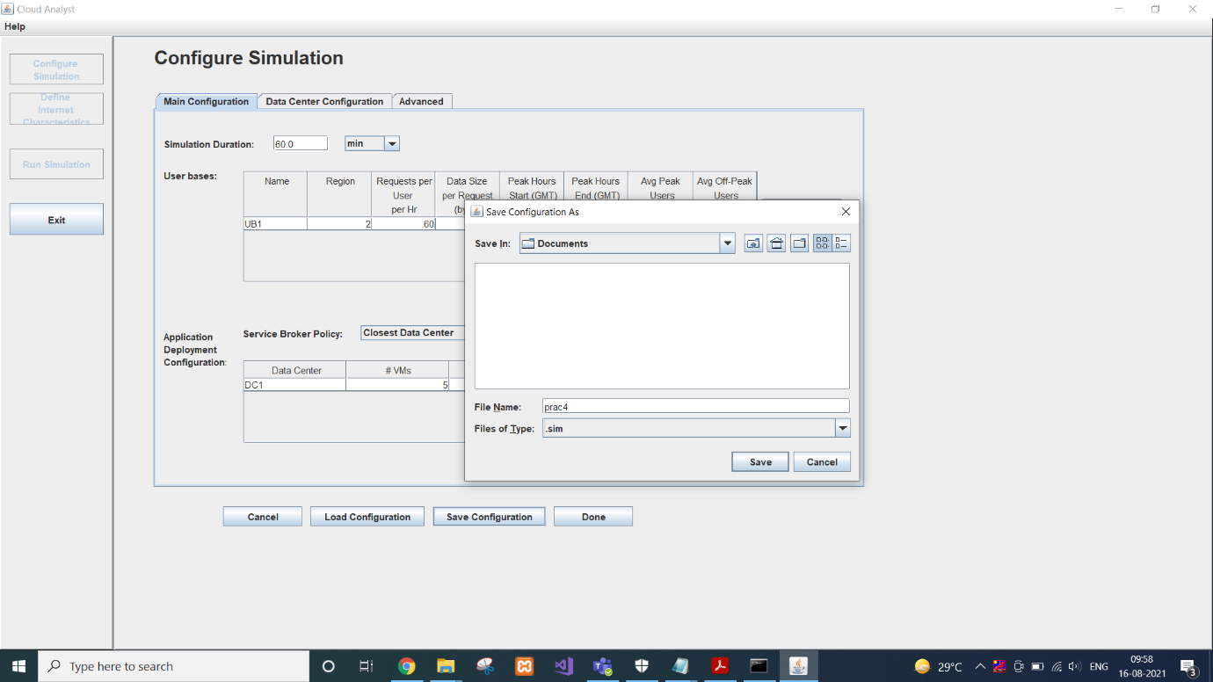

* Saved configuration can be loaded anytime easily into CloudAnalyst.
* So you need to enter data each time you want to run simulation.
* Once your are done with Configuration; click on Done!!!
* We can check bandwidth and delay between regions in “Define Internet Characteristic”

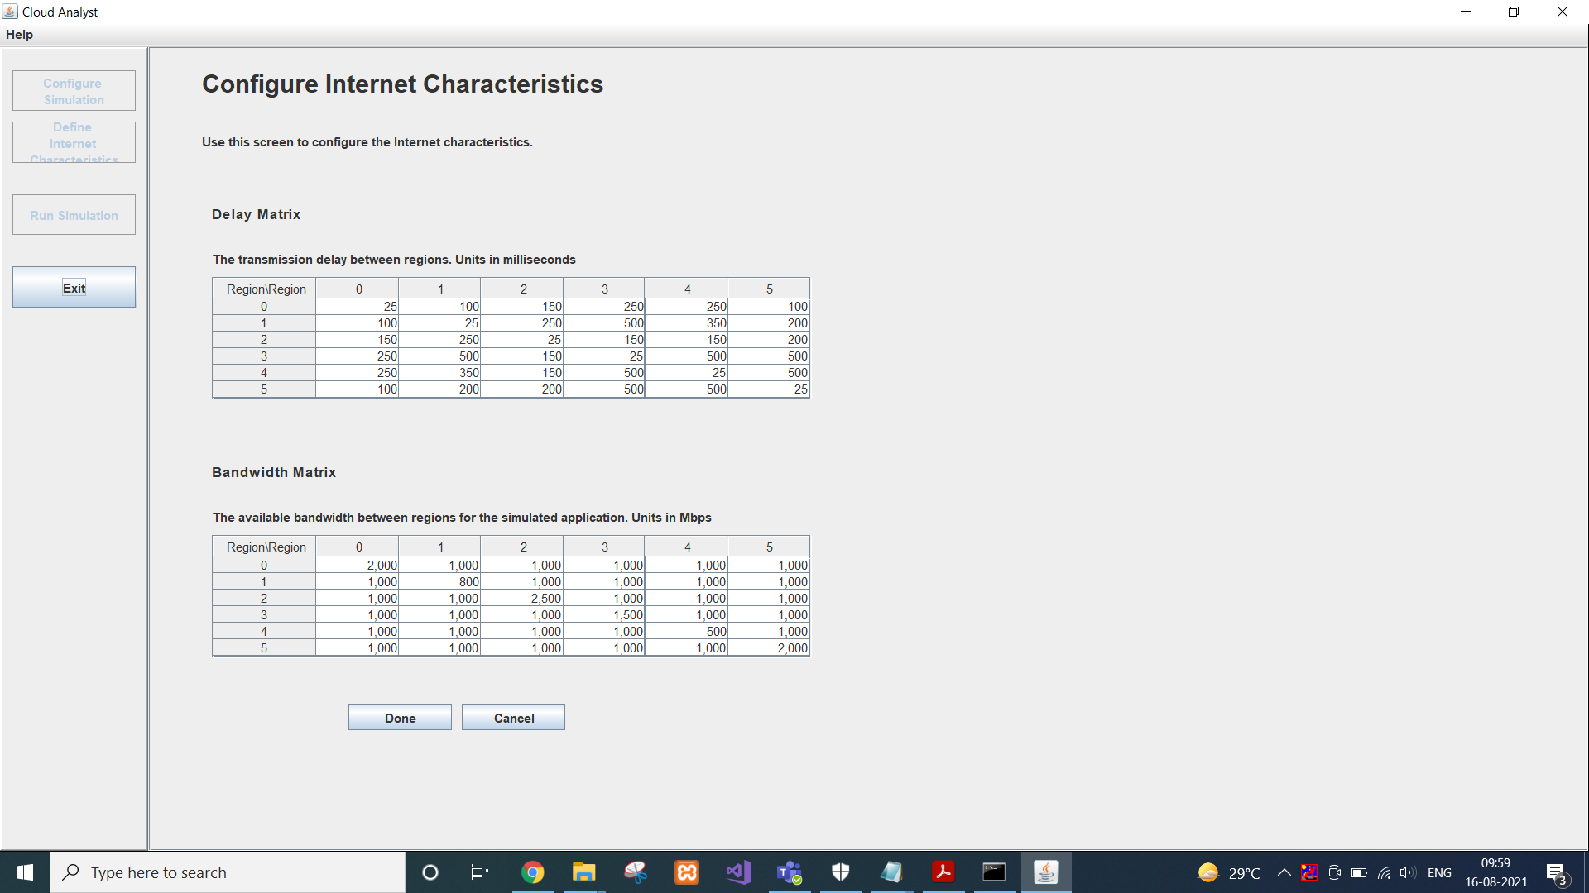

* Then we can run simulation that would give us overall report of simulation.

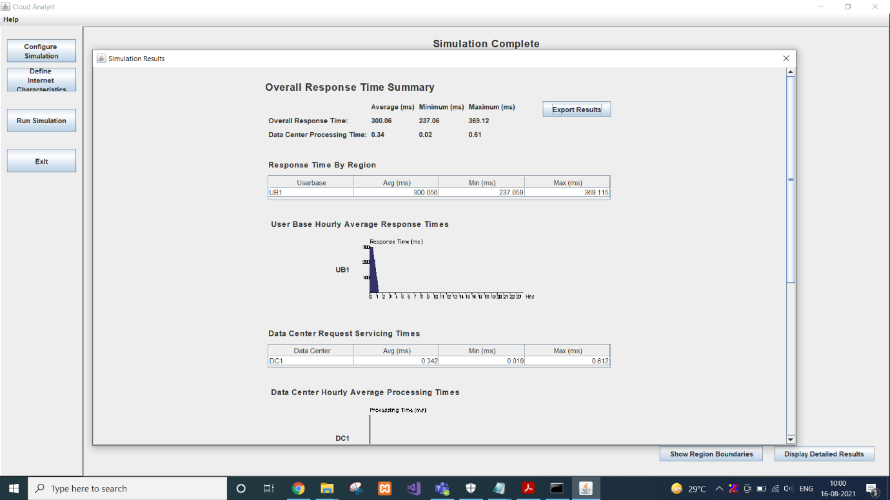

* We can close it.
* Main Window will give all statistics.

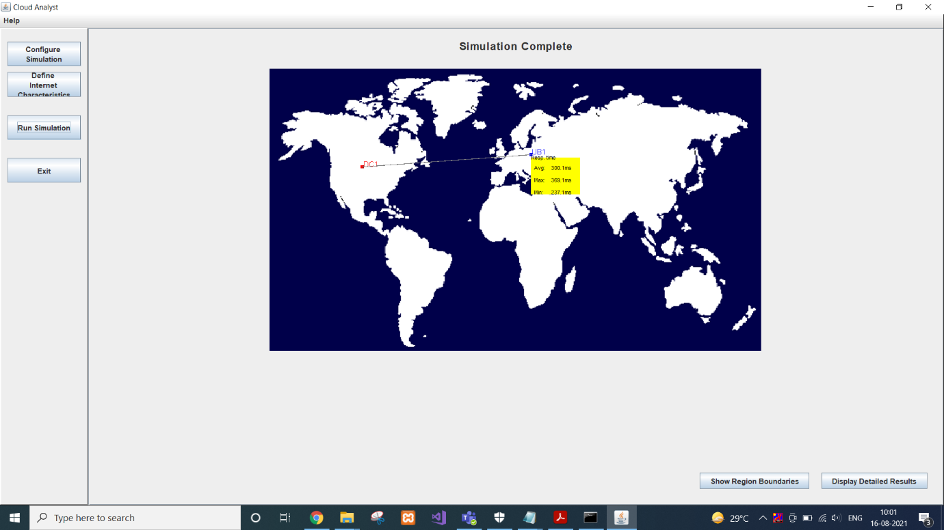

**CONCLUSION**

In this practical, I learnt the basics of cloud analyst and it’s application.